Experiment No. 2

Aim:
Implement Multi Regression, Lasso, and Ridge Regression on real-world datasets

Theory:
In machine learning, predicting outcomes often requires analyzing relationships between multiple input variables and the target variable. Multiple Regression, Lasso Regression, and Ridge Regression are techniques used for this purpose, especially when dealing with real-world datasets that have many features.

Multiple Regression
Multiple Regression is an extension of linear regression where more than one input variable is used to predict a continuous output.
Purpose:
- To understand how multiple factors influence a target outcome. ● To predict numerical values based on several features.
Real-World Applications:
- Predicting house prices based on size, location, and number of rooms.

- Estimating sales revenue based on advertising, season, and product type.

- Forecasting employee performance using experience, education, and hours worked.

Key Idea:
It helps identify which factors are most important and how they collectively affect the output.

Lasso Regression
Lasso (Least Absolute Shrinkage and Selection Operator) Regression is a type of regression that performs feature selection while predicting outcomes.
Purpose:
- To handle datasets with many features by automatically selecting the most important ones.
- To prevent overfitting by simplifying the model.

Real-World Applications:
- Selecting key factors affecting customer churn from a large set of features.
- Identifying important medical variables for predicting disease risk.
- Reducing complexity in financial models with many correlated variables.
Key Idea:
Lasso regression keeps the model simple and interpretable by shrinking less important feature contributions to zero.

Ridge Regression
Ridge Regression is another regularization technique that is used when there is multicollinearity (high correlation) among input variables.
Purpose:
- To prevent overfitting in datasets with many correlated features. ● To improve the stability and accuracy of predictions.
Real-World Applications:
- Predicting stock prices when many economic indicators are correlated.
- Forecasting energy consumption using correlated weather and usage data.
- Handling large datasets in marketing analytics where features are highly interdependent.
Key Idea:
Ridge regression reduces the impact of less important or correlated features without removing them, unlike Lasso.
Implementation:
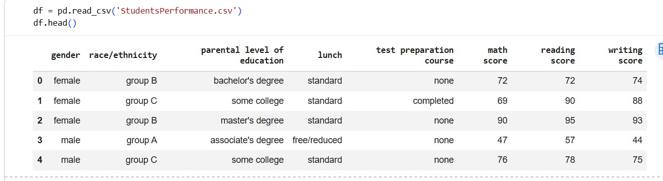

Read

Data

Multi regression
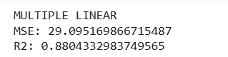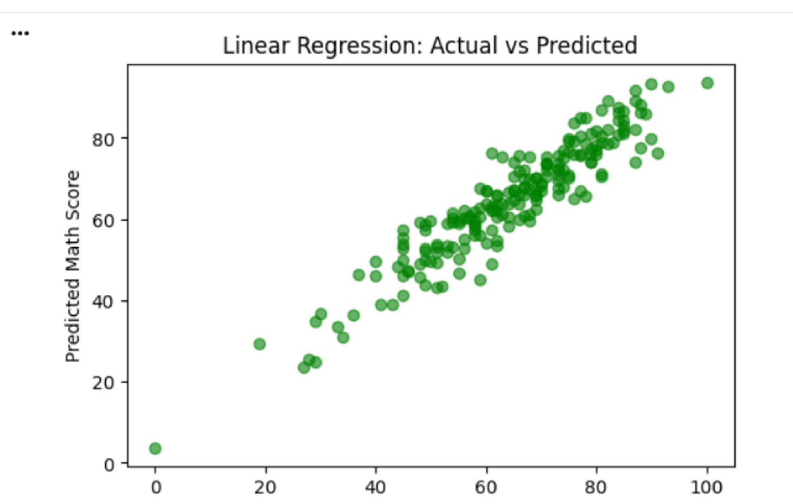

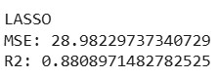
Lasso

regression

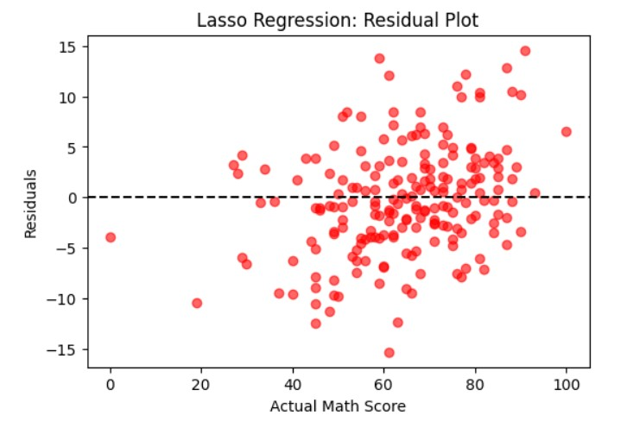

Ridge regression
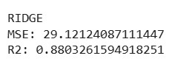

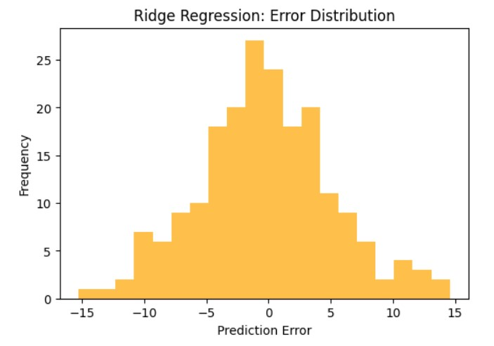

Conclusion:
Multiple Linear, Lasso, and Ridge regression were applied on the Kaggle Students Performance dataset to predict math scores. The graphs show that Linear Regression fits the data well, Lasso reduces some extreme errors, and Ridge produces a balanced error distribution, demonstrating how regularization improves model stability.

